Code No.: |  | HTU/P12 |  | Date Established | 9/11/2017
Responsible  Department |  | All Departments |  | Date Posted | 9/11/2017
Responsible Executive |  | Programme Leaders/Deans |  | Date Last Revised  Revision # 4 | 10/11/2023
Quality Nominee |  | Rumiana Bahova Nuseibeh |  | Forward Revision Date | 10/11/2024

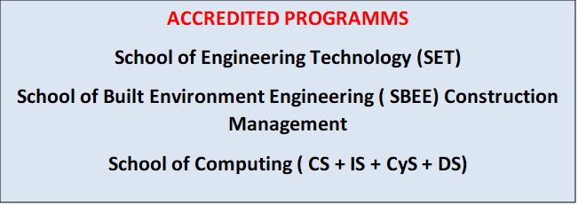

This Document was last revised : 10th November 2023

Learner support Policy

- Introduction
• The purpose of this policy is to ensure that all learners receive the necessary advice, guidance and support in order to optimize their achievement on courses that are completely appropriate to their needs. ( Open days induction sessions are scheduled across all qualifications prior to admission in addition to a personal interview after a candidate has been shortlisted.

- Ethos & aims

• All learners will receive advice or information specific to the course on which they wish to enroll. All Learners will receive an initial and diagnostic assessment and an induction. See Learning Recruitment & Selection Policy.

• The procedures and practices which fall under Learner Support will reflect the Mission Statement, Values and Strategic Objectives of the Service.

• The Service endeavors to make the courses and learning as accessible as possible, in line with our Equality& Diversity Policy and our Disability Statement.

- Responsibility & scope
• This policy covers all learners and all academic, learner support and enrolment staff who are involved in learner guidance and support.

- Implementation

The following are the responsibility of admissions and enrolment staff & Tutors:

1. All learners will be encouraged to disclose their additional support needs before starting a course.
2. The need for Learning Support will be captured through: the telephone hotline, the enrolment form, initial assessment, and tutors’ monitoring of learners during the course.
3. Additionally, information on Learning Support and other support services will be provided to learners in the Prospectus, Learner Handbook and in other leaflets displayed at reception desks. Learning support staff will visit classes to explain the services available to learners.
4. Learning Support will be included in the staff induction process. Tutors will also have relevant information in their handbooks.
5. Learning Support Coordinators will liaise regularly with tutors to discuss individual learner progress and the provision of support.
6. All learners who identify additional support needs will be invited for a personal interview (wherever appropriate) where the learner will discuss and agree to a learning support plan.
7. Learning support will be provided on an appropriate basis which will include 1:1 support, group support, classroom support, specialist assessment, drop-in sessions, IT support and specialist equipment.
8. During extenuating circumstances, like Pandemics, HTU will make sure to provide the necessary learner’s support and orientations online through virtual platforms.
8. The Learning Support office will document the type of the support provided and progress towards agreed goals. The Learning Support review document will be reviewed regularly by learner and tutor who will sign and date each review.

9. All learners will have access to the Learning Centres for open and flexible learning, careers guidance information and inexpensive photocopying and printing. Staff will be on hand to assist, advise and support learners and provide induction sessions on the computers.
10. Free careers guidance will be available to all learners and prospective learners from a fully qualified and experienced Careers Adviser. Learners will be entitled to attend a personal interview and regular workshops. Our Careers Service holds the Matrix award.

11. Learners will be provided with information on available grants including the Learner Support Fund and the Learner Association hardship fund.

The following are the responsibility of Academic staff in the Deanships:

1. Heads of Faculty will ensure Learning Support staff are involved in termly Course Review meetings where appropriate.

2. All learners will receive regular and constructive feedback from tutors on their progress. Progress of learners will be clearly documented. See our Assessment Policy and Learner Recruitment & Selection Policy.

3. Drop in/study skills workshops will be offered to all students.

- All learners will receive comprehensive advice on progression routes.

5. Basic Skills awareness training will be made available to all staff who require it.

The following are the joint responsibility of staff in Learner Support and Teaching & Learning

1. When it is not possible for the Service to meet the support needs of a learner then that learner will be referred to other provision.
2. All learners will have the opportunity to evaluate the advice, guidance and support they have received.
3. The Learning Support Staff will regularly monitor provision through: learner, tutor and curriculum manager feedback, line management meetings and achievement data.

- Monitoring

The operation of this policy is monitored and evaluated through:
• The Annual Self-assessment Report
• Monthly monitoring reports
• Reports to the Governors Performance Monitoring Review Committee on self-assessment and development plans
• Reports to the Executive Board of the Service
• The policy is reviewed every year by the Director of Teaching & Learning

- Review This policy may be read in conjunction with the Learner Recruitment and Selection Policy and the Assessment Policy.

End of Policy.

